Omeo Primary School
Everyone has the right to feel safe. Everyone has the right to be able to learn and teach.
 | All Settings  Everywhere,  All the time  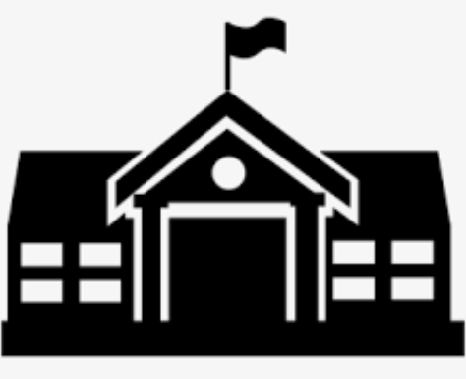 | All Learning Time | 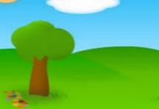  Outside spaces | 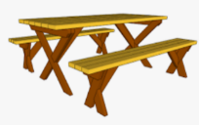  Lunch Area | Toilets | School Events,  Assembly, Excursions | Esmart  IPads, computers  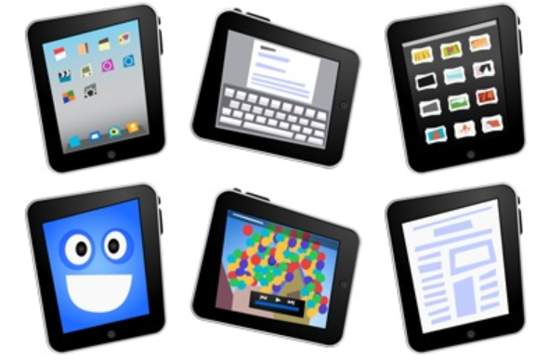
Respect  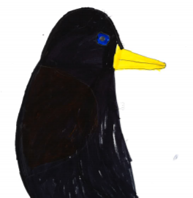  Riana Penguin | I am safe with my words and actions  I use all equipment responsibly, safely, and respectfully | We work well with others and let others learn  I demonstrate the 5 Ls of listening. | I respect others personal space and ask to join games. | I walk in the slow zone.  I remain seated while eating. | I respect toilet equipment and the privacy of others  I wash my hands properly and turn the taps off. | I participate respectfully in school events  I display safe behaviour travelling to school and on excursions | I follow my ICT agreement
Inclusion  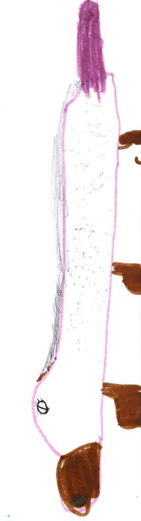  Izzac Inclusion | I get along with everyone | I help others by being encouraging | I help others feel safe. | I will sit next to anyone |  | I acknowledge and celebrate other people’s successes.
Persistence 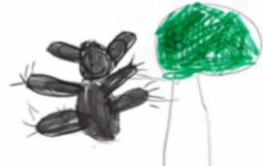  Pippa Possum | I keep trying | I ask for help | I am persistent in games. | I eat my lunch. |  | I help to make activities and events successful | I work through technical issues as quick as I can.
Enjoyment  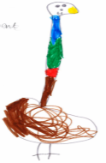  Emma Emu | I celebrate effort and success of myself and others |  | I have fun with my friends.  It’s O.K to play by myself sometimes. | I enjoy having lunch with my friends |  | I contribute to school assemblies and excursions. | I enjoy technology without disrupting others.
Excellence 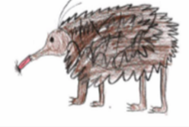  Eddie Echidna | I am the best I can be. | I put in my best effort and track this even when it’s hard | I demonstrate good sportsmanship. |  | I try to use the toilets before school and in the breaks. | I represent my school and community with pride.

